Certificates with ORM stack

Contents

1. Introduction 3
2. Workflow diagram to deploy the stack 3
3. Create stack for Certificates 4
4. Plan the Job 6

Introduction

A certificate proves the identity of its bearer and provides proof of ownership of the public key included with the certificate. Certificates are presented for SSL/TLS server and client connections, email encryption, code signing, and electronic signatures.

Workflow diagram to deploy the stack

Below diagram shows how the Terraform Artifact are applied in the OCI. While creating a ORM stack, using terraform deliverables Init, Plan and Apply is the flow to provision the resource in the OCI. We can have the deliverables in any of below.

- GitLab/GitHub Repo
- Bitbucket
- Can be in folder/.zip in the local disk
- Object Storage Bucket
- Can be in compartment
- Oracle provided Template

Prerequisite
- Create Certificate Authority
- Create IAM Policies

Create stack for Certificates

Go to OCI Console Developer Services Resource Manager Stacks select the compartment Create Stack

My Configuration Folder Browse Select the “Certificate_CA” folder that contains the terraform Upload

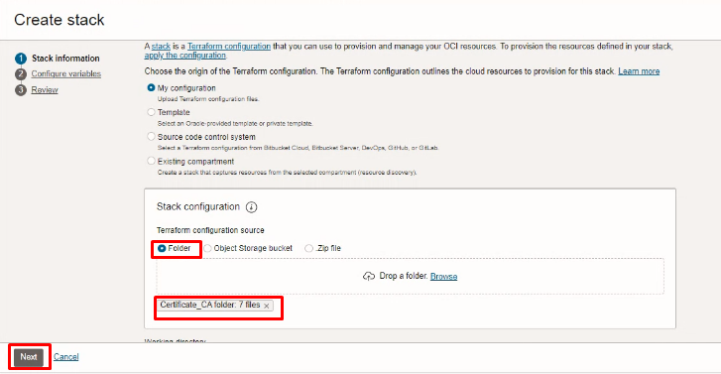

Select the parameters as per the below screen,
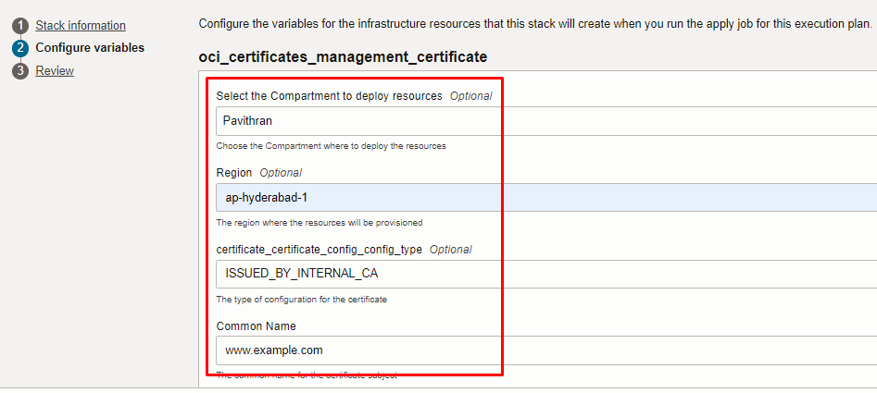

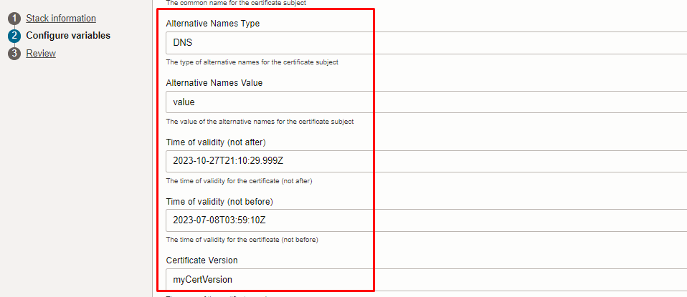
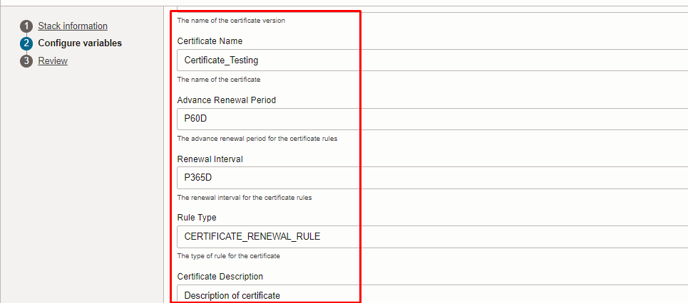
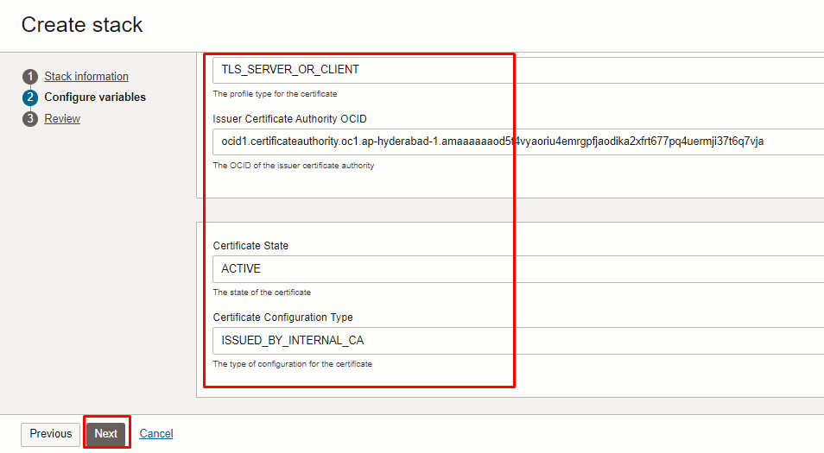
Click “NEXT”
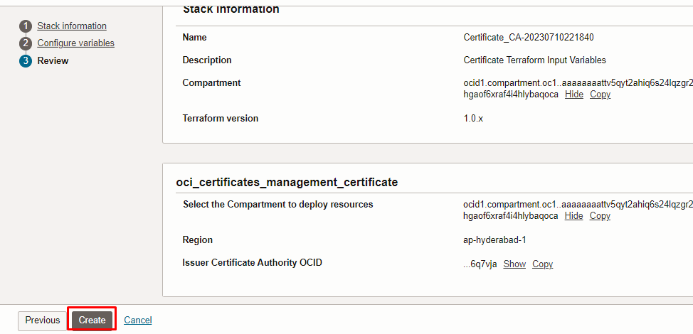
Click “CREATE”

Plan the Job

Click the “Plan”
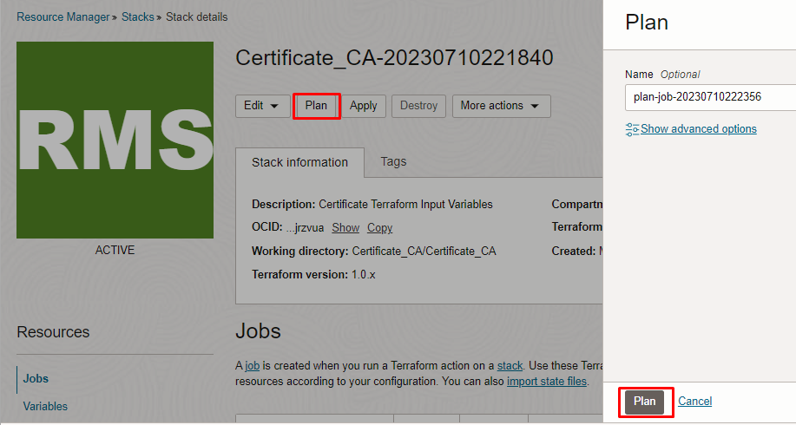

Verify the Plan is successful.

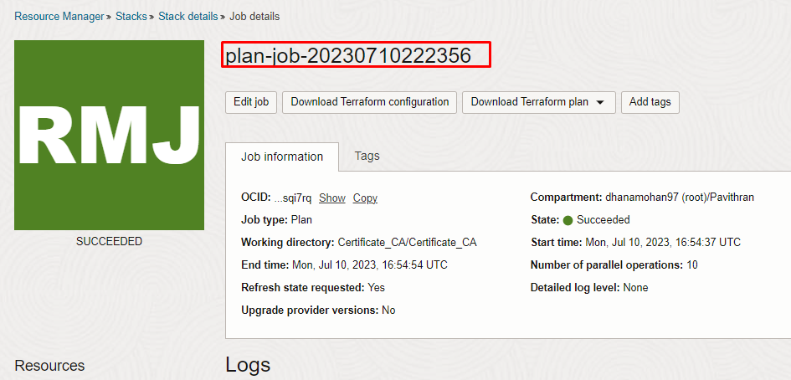
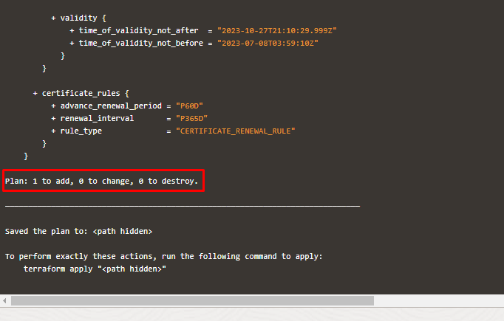

#END#

